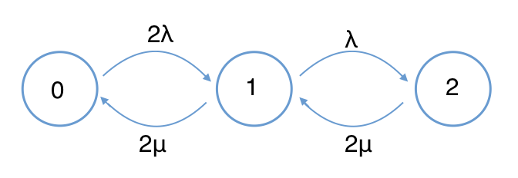**Q1.** λ=1/10 µ=1/8

1. hire another repair man:

Stage 0: 2µ π1 = 2λπ0

Stage 1: 2λ π0 + 2µ π2 = (2µ+ λ) π1

Stage 2: λ π1 = 2µ π2

Normalize: π0 + π1 + π2 = 1

C0 = 1 π0 = ≈ 0.4717

C1 = = 0.8 π1 = 0.8 * 0.4717 ≈ 0.3774

C2 = = 0.32 π2 = 0.32 * 0.4717 ≈ 0.1509

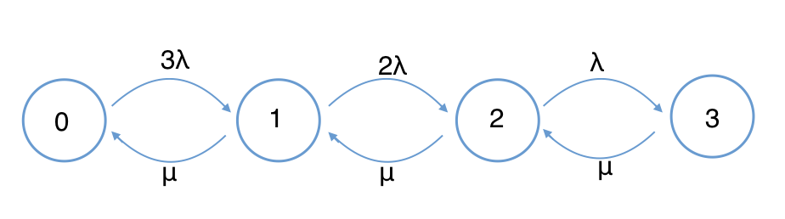Throughput.a = 2π0 + 1π1 = 2 * 0.4717 + 0.3774 = 1.3208 (avg. # machines working)

1. buy another machine:

Stage 0: µ π1 = 3λπ0

Stage 1: 3λ π0 + µ π2 = (µ+ 2λ) π1

Stage 2: 2λ π1 + µπ3 = (µ+ λ) π2

Stage 3: λ π2 = µπ3

Normalize: π0 + π1 + π2 + π3 = 1

C0 = 1 π0 = ≈ 0.09697

C1 = = 2.4 π1 = 0.9697 * 2.4 ≈ 0.23273

C2 = = 3.84 π2 = 0.9697 * 3.84 ≈ 0.3724

C3 = = 3.072 π3 = 0.9697 * 3.072 ≈ 0.2979

Throughput.b = 3π0 + 2π1 +1π2 = 1.11288 < 1.3208 (Throughput.a)

thus hire another man would be provide more productivity

**Q2.** λ=20arrivals/h μ=27arrivals/h

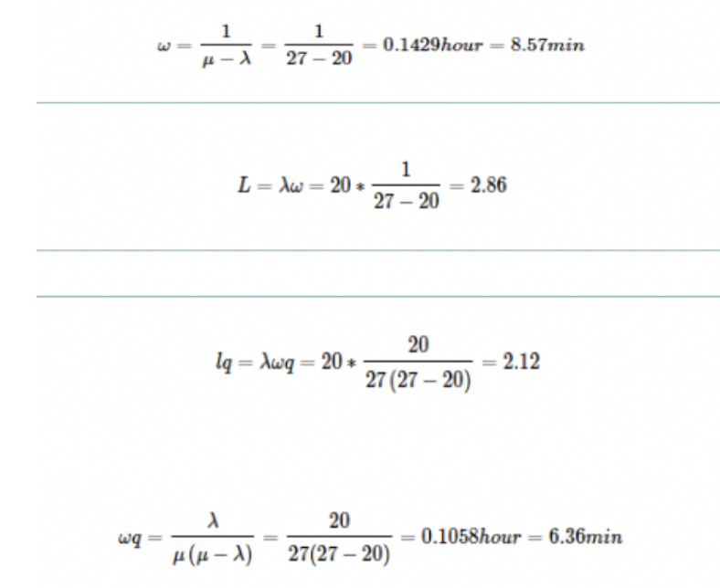

**Q3**. λ′=25 arrivals/h μ′= 27arrivals/h

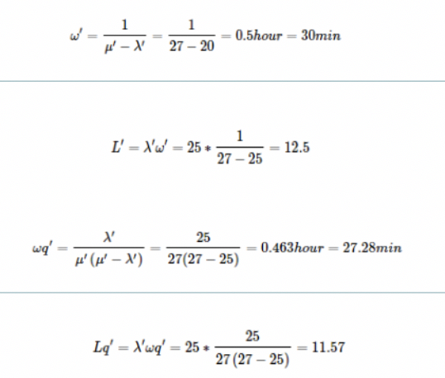  
**Q4**

